WEEK-2 2520030531
D. Venya Sri

Step 1 — Create Database
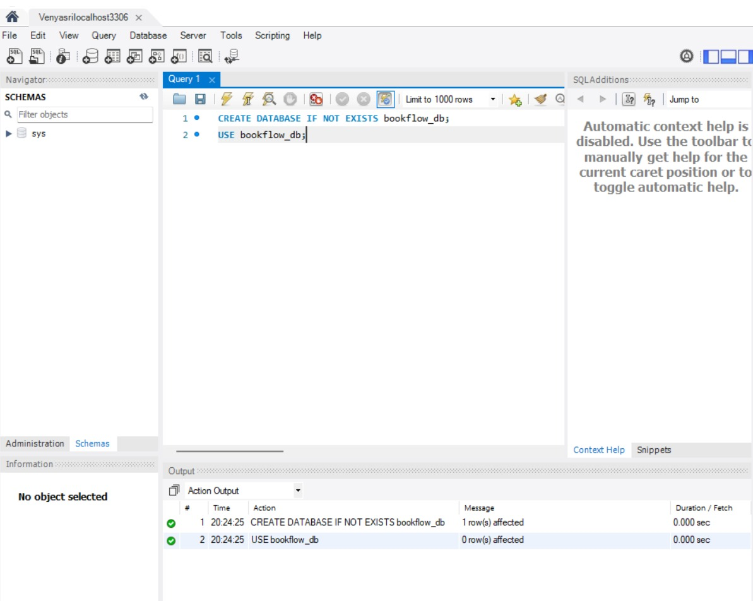
Step 2 — Create Books Table (DDL + Constraints)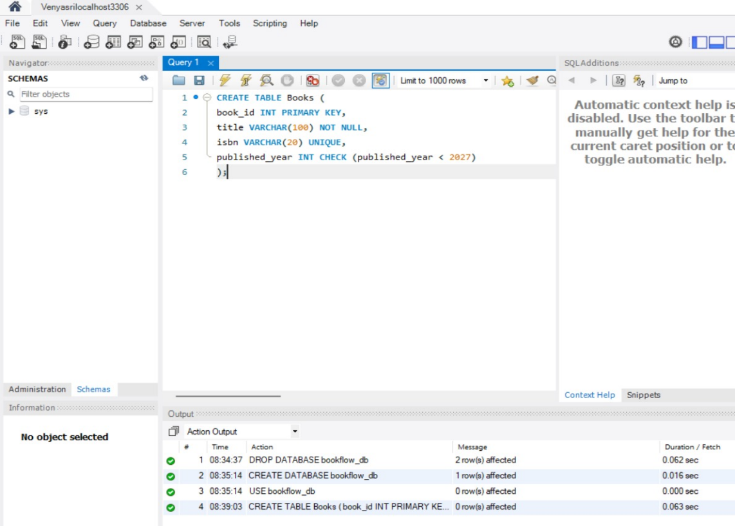

Step 3 & 4 — Insert Books and Display
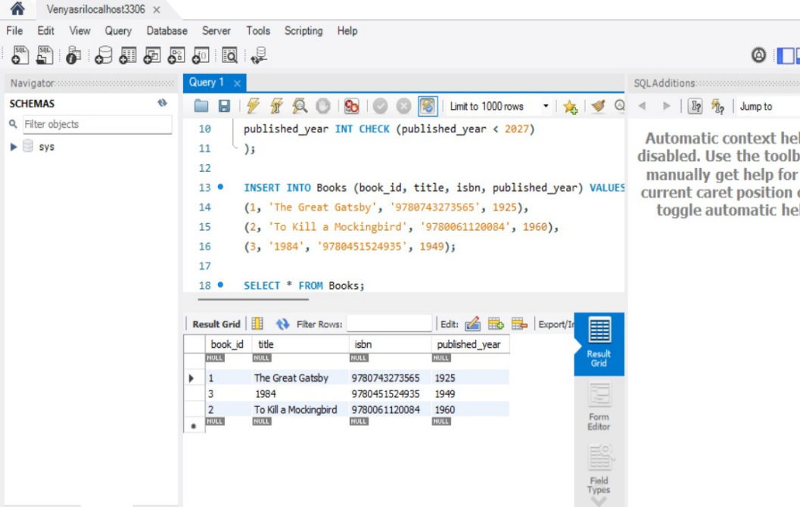
Step 5, 6 & 7 — Members Table: Create, Insert, Display
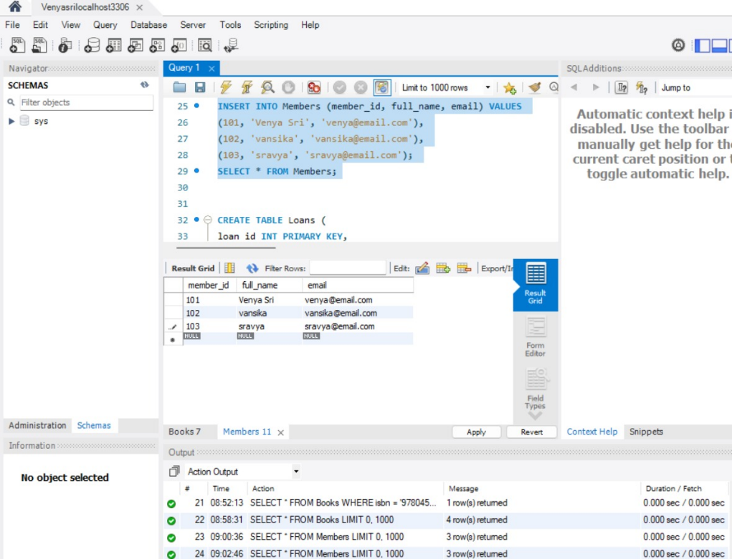

Step 8, 9 & 10 — Insert 10 Loans and Display
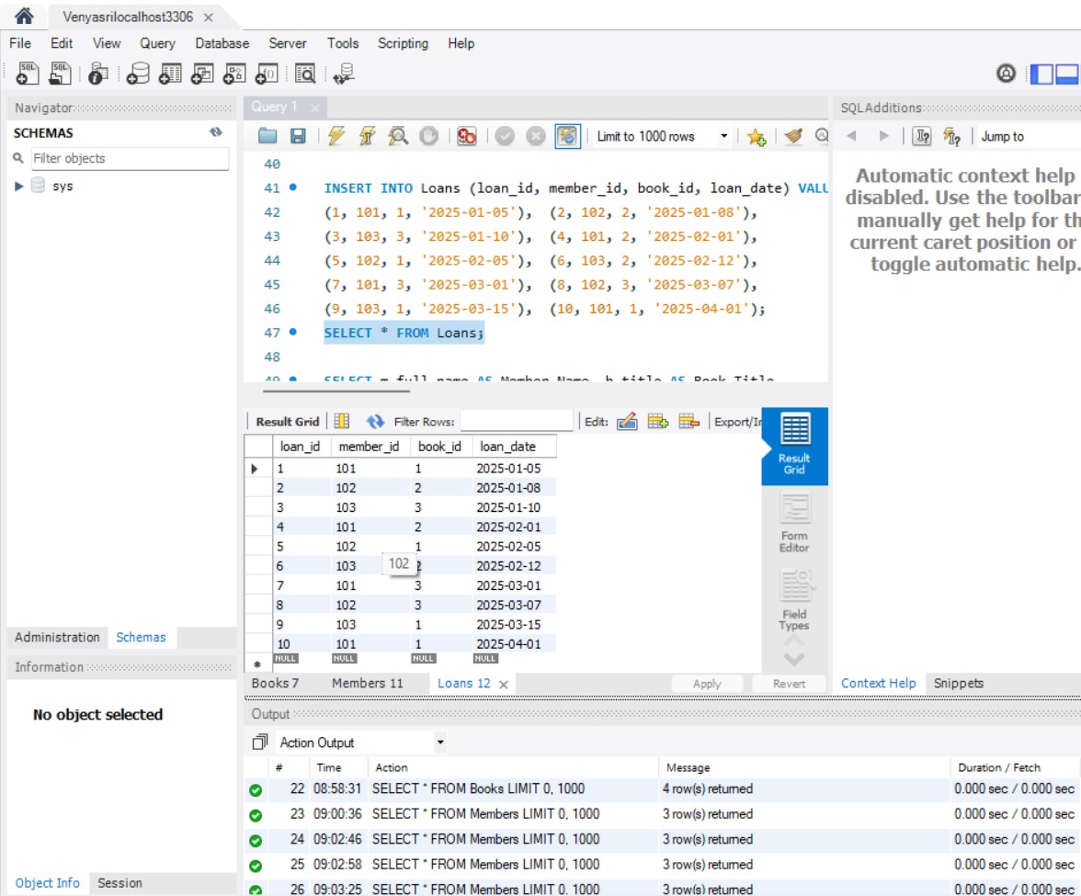

Step 11 — JOIN Query (Who Borrowed What)
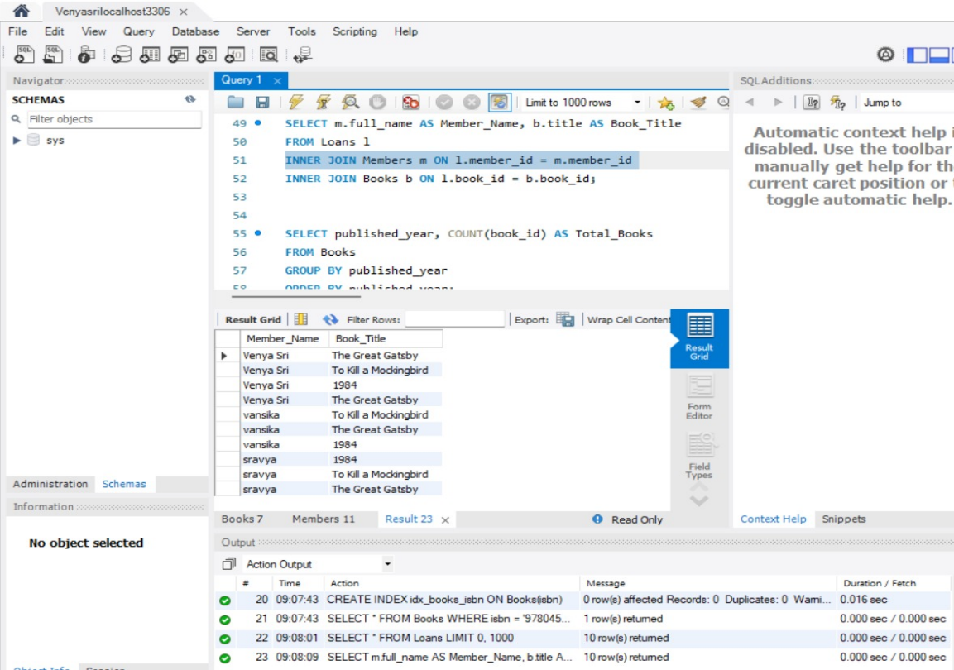
Step 12 — GROUP BY Query (Books per Year)
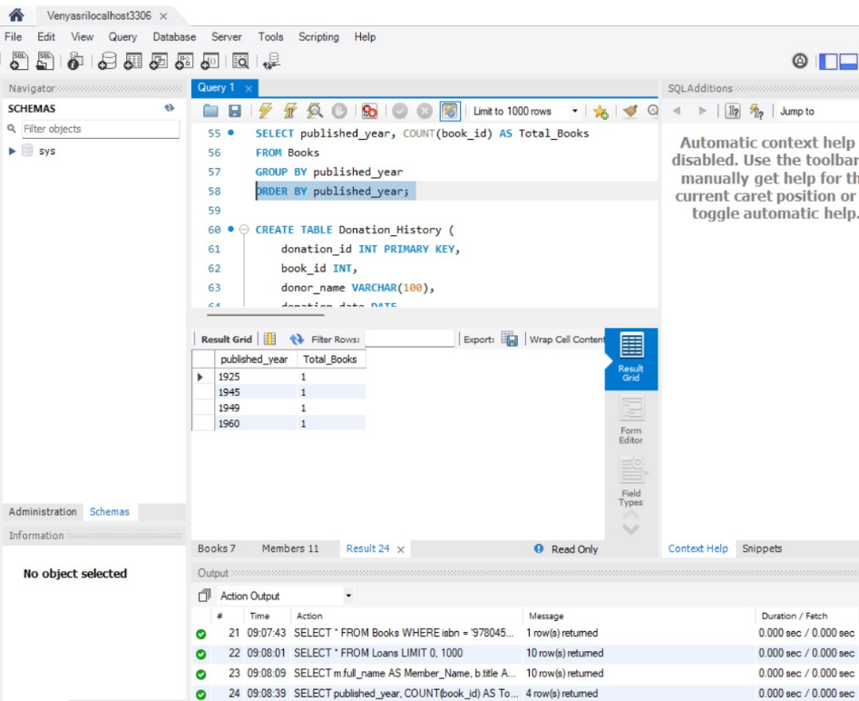
Step 13–16 — Donation via TRANSACTION (Atomicity)
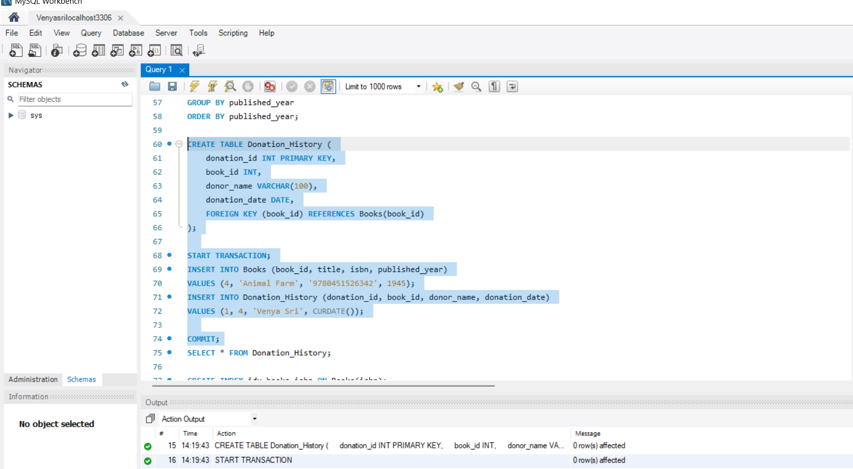

Step 17 & 18 — Index on ISBN + Fast Search

